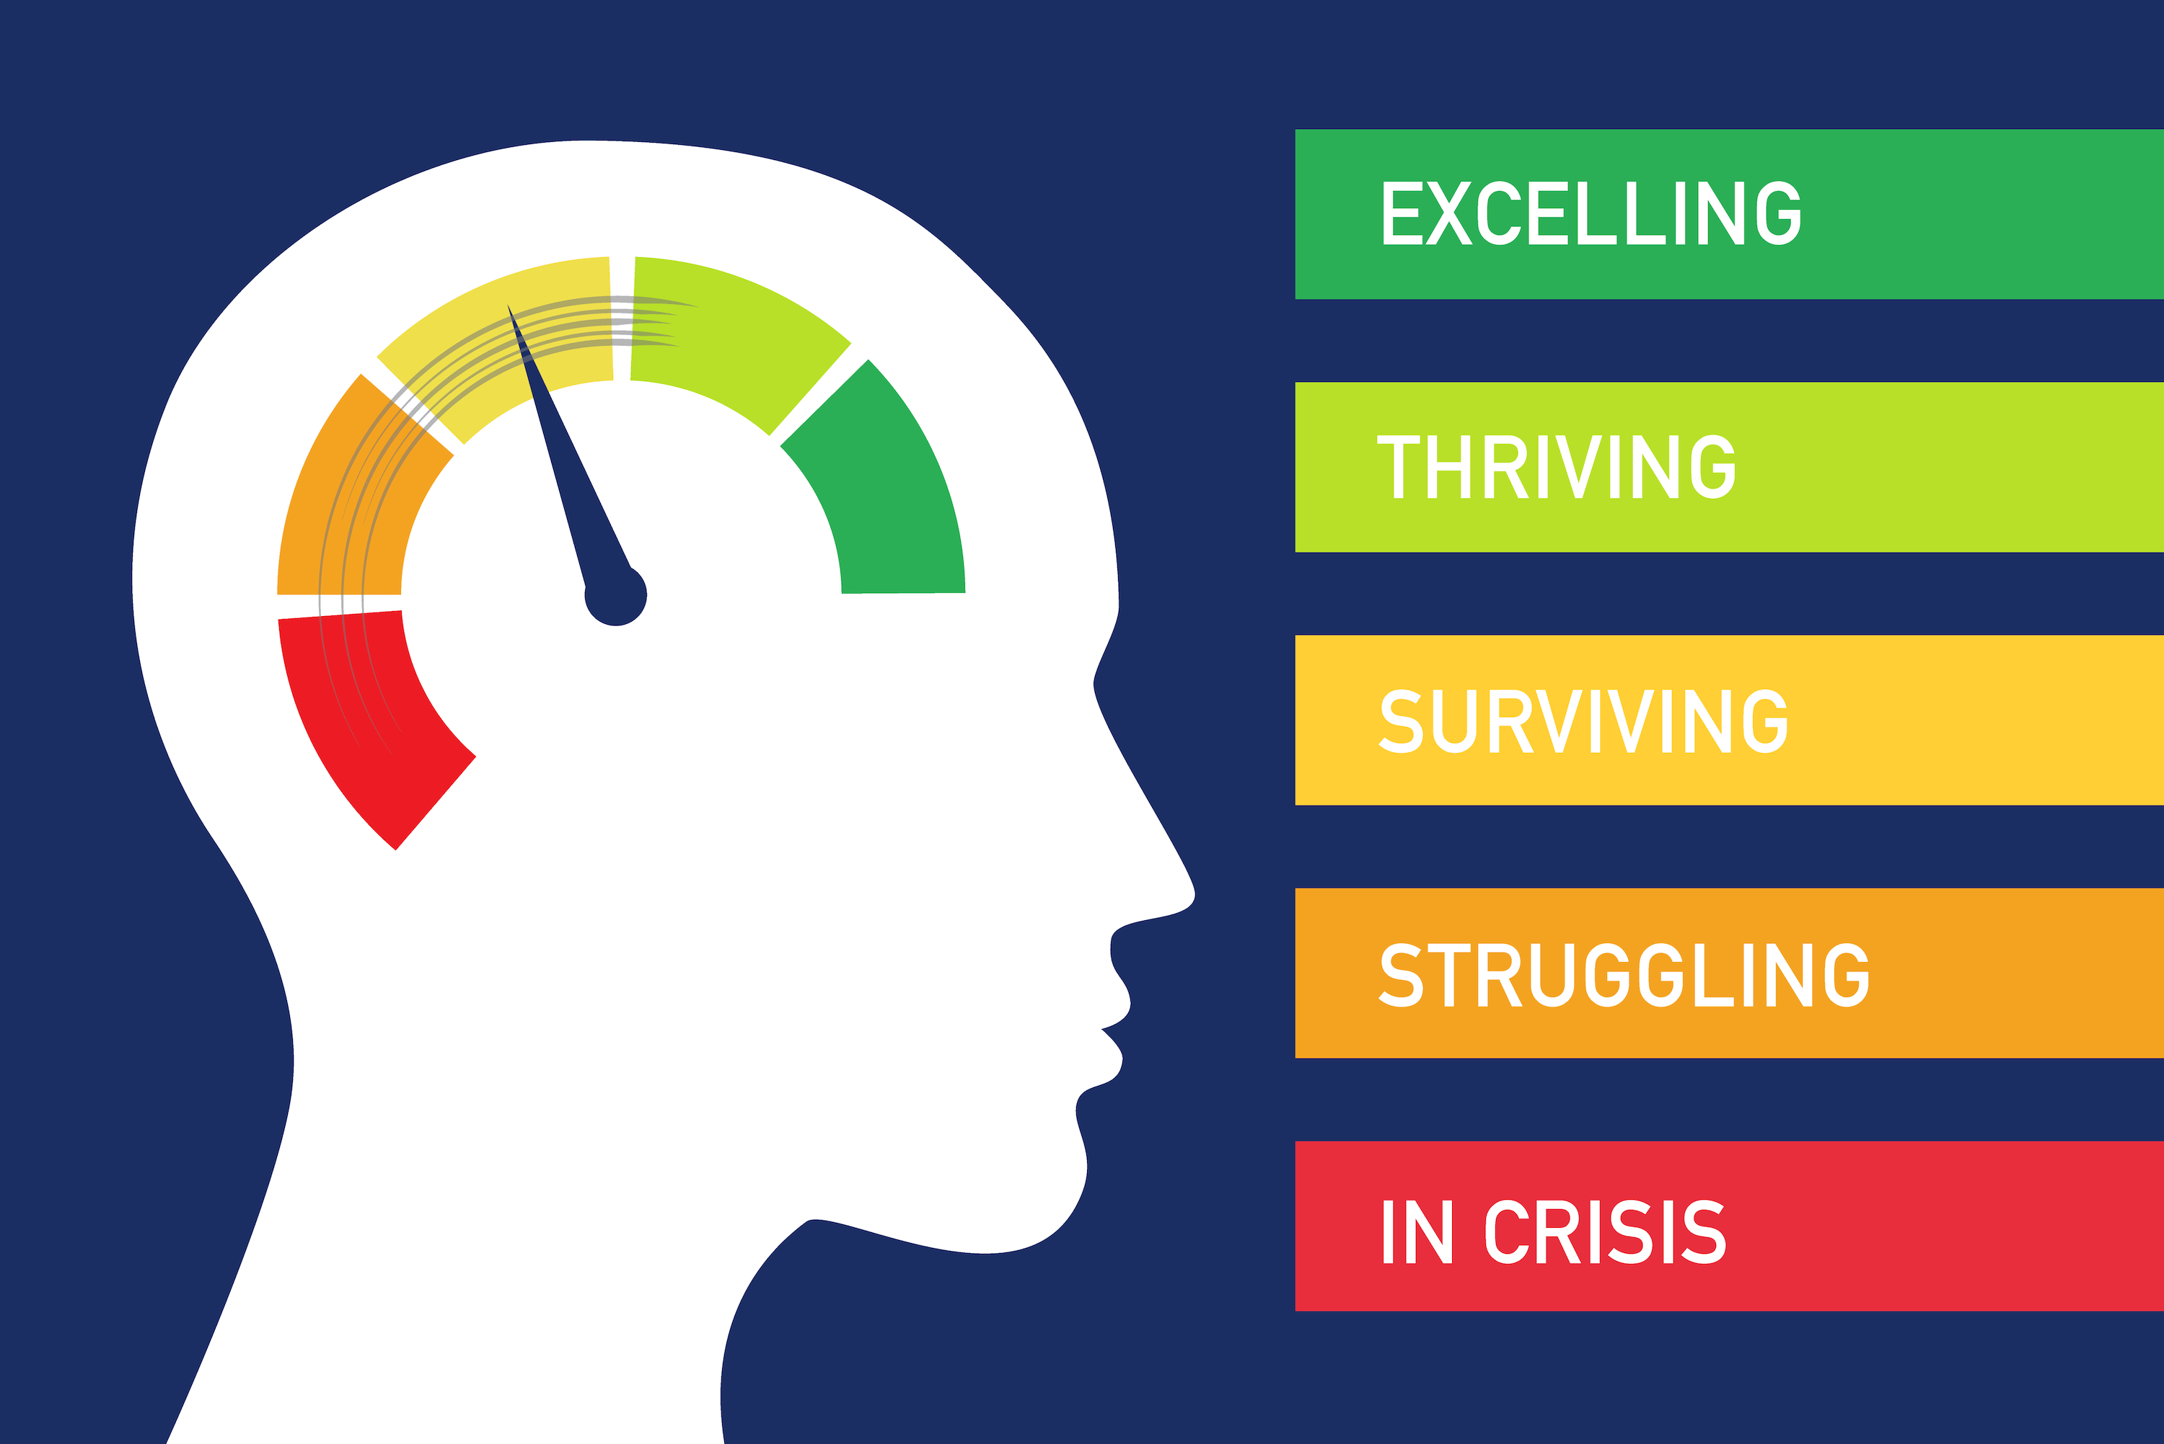

Are you concerned about mental health or wellbeing? The last few years have been challenging for many people including children. If you’re concerned about your child’s worries, sleep, diet, mood, behaviour, inactivity or risk – look through the information below and click on a relevant link from the list of organisations you can contact for support.

Safe Havens Walk in Centres
https://www.sabp.nhs.uk/our-services/mental-health/safe-havens
Safe Havens provide out of hours help and support to people and their carers who are experiencing a mental health crisis or emotional distress.
They are open evenings, weekends and bank holidays and are designed to give adults a safe alternative to A&E when in crisis (please see individual services for detailed opening times).
Each Safe Haven is staffed by a mental health practitioner from Surrey and Borders Partnership and two trained Safe Haven workers. Peer support from people with lived experience of mental health issues is also increasingly available.
The Safe Havens are provided by a partnership between our Trust and third sector mental health specialists which is funded by Surrey and north east Hampshire NHS Clinical Commissioning Groups. See links below for individual details.
- Safe Haven, Aldershot
- Safe Haven, Epsom
- Safe Haven, Guildford
- Safe Haven, Redhill
- Safe Haven, Woking

Crisis Line
https://www.sabp.nhs.uk/our-services/mental-health/CrisisHelpLn
Mental Health Crisis Helpline on: 0800 915 4644

Talking Therapies
https://dhctalkingtherapies.co.uk/
Talking therapies are designed to help with common mental health problems.
The NHS service is free, confidential and available throughout Surrey for people 17+ who are registered with a Surrey GP.

Kooth
https://www.kooth.com/
Your online mental wellbeing community. Free, safe and anonymous support

Shout Crisis Textline
If you need immediate support, you can text SHOUT to 85258 and chat by text. The service is free on most networks and available 24/7, and trained volunteers will listen to you, and work with to help you take the next steps towards feeling better.

The Mix
https://www.themix.org.uk/get-support
0808 808 4994
The Mix offer slots for One-to-one or Group support. They operate 7 days/week.

YoungMinds
https://youngminds.org.uk/find-help/
YoungMinds run a free, confidential parents helpline, which parents / carers can call if they are worried about how a child or young person is feeling or behaving. They also run a group called Parents Say, for parents whose children are accessing Child and Adolescent Mental Health Services.
Are you a young person in crisis?
Text the YoungMinds Crisis Messenger for free 24/7 support across the UK if you are experiencing a mental health crisis.
If you need urgent help, text YM to 85258.
All texts are answered by trained volunteers, with support from experienced clinical supervisors.
Texts are free from EE, O2, Vodafone, 3, Virgin Mobile, BT Mobile, GiffGaff, Tesco Mobile and Telecom Plus.

Relate
https://www.relate.org.uk/relationship-help/talk-someone
Relate offers a range of digital and telephone counselling services. We have increased the availability of our experienced webcam, telephone and Live Chat counsellors ready to help you right now. Due to COVID-19, all our face-to-face services are temporarily closed.
For any general enquiries or to book an appointment, phone 0300 0030396 or contact your nearest local Relate.

Samaritans
Need support? We're here to listen 24 hours, 365 days a year. Call 116 123 for free or email jo@samaritans.org

NHS 111
Call 111 for 24h/day access to advice. If you’re concerned 111 may provide some helpful tips and organisations to contact.

GP
Contact your GP if your concerns are getting serious, especially if your child is having period thoughts of suicide or self-harm.

A&E/999
If you consider your child to be at immediate risk or somebody else is at risk, then call 999 or take them direct to A&E.

