Mental Health Team at Oakfield
Oakfield Junior School is committed to ensuring the welfare and safety of all our pupils in school.
We are committed to supporting the emotional health and wellbeing of our pupils and staff.
We have a supportive, inclusive and caring ethos and our approach is respectful and kind,
where each individual and contribution is valued.
At our school we know that everyone experiences life challenges that can make us vulnerable
and at times, anyone may need additional emotional support.
Whilst all staff have a responsibility to promote the mental health and well-being of pupils,
staff members listed below can ensure that staff, pupils and parents are aware of
what support is available within our school and how to access further support.




Debbie Willemse
Headteacher & Designated Safeguarding Lead
head@oakfield.surrey.sch.uk
Mental Health Level 3
Staff Mental Health First Aider
Jenny Mare
SENco & Centre Manager
jenny_mare@oakfield.surrey.sch.uk
Mental Health Level 3

Emily Buckler
PSHE (Personal, Social, Health Education) Lead & Deputy Designated Safeguarding Lead
emily_buckler@oakfield.surrey.sch.uk
Mental Health Level 3

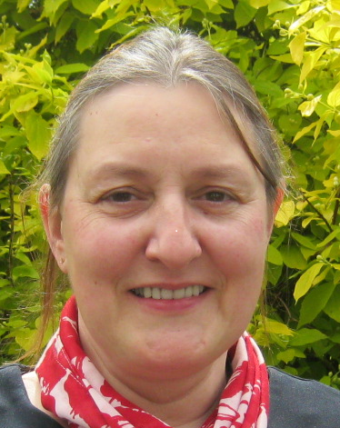


Michaela Mason
ELSA Emotional Literacy Support Assistant
michaela_mason@oakfield.surrey.sch.uk
Mental Health Level 2


Sharon George
Thrive Practitioner
sharon_george@oakfield.surrey.sch.uk
Mental Health Level 2

Simon Barrett
Thrive Practitioner simon_barrett@oakfield.surrey.sch.uk
Mental Health Level 3

Helen Bell
ELSA Emotional Literacy Support Assistant
helen_bell@oakfield.surrey.sch.uk
Mental Health Level 3

ALL STAFF are here to help you feel safe and supported
If are concerned about the mental health and well-being of someone else,
you can speak to any member of staff including
anyone on the mental health and well-being team above.

