[Type a quote from the document or the summary of an interesting point. You can position the text box anywhere in the document. Use the Text Box Tools tab to change the formatting of the pull quote text box.]

Using your fact sheet, answer all the questions on this worksheet, and when you’re done, you’ll know much more about how special our Rainforests are!
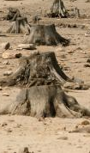
If 2 U.S. football fields are destroyed every second, how many football fields are destroyed in 5 seconds?
_____________________________
_____________________________
_____________________________

What does deforestation mean?
_____________________________________
_____________________________________
_____________________________________

Where is the largest rainforest in the world?
(Circle your answer)
a) The Philippines
b) The Congo Basin in Central Africa
c) Peru
d) The Amazon Basin of South America

True or False: Rainforests contain over half of all plant and animal species in the world? (Circle your answer)
True
False
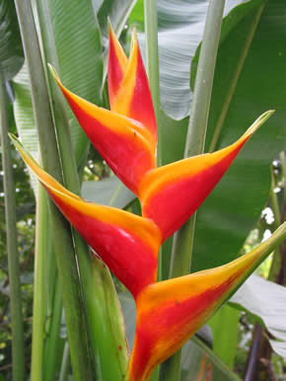

Fill in the blank.
One environmental consequence of deforestation is __________. This happens when heavy rains wash nutrients from the soil.
Name two things you can do as a person to try and stop deforestation.
1) ________________________________
__________________________________
2)________________________________
__________________________________

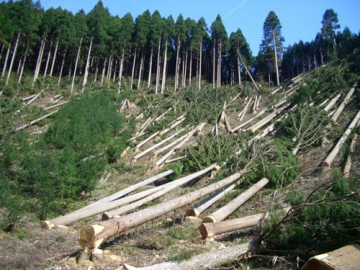
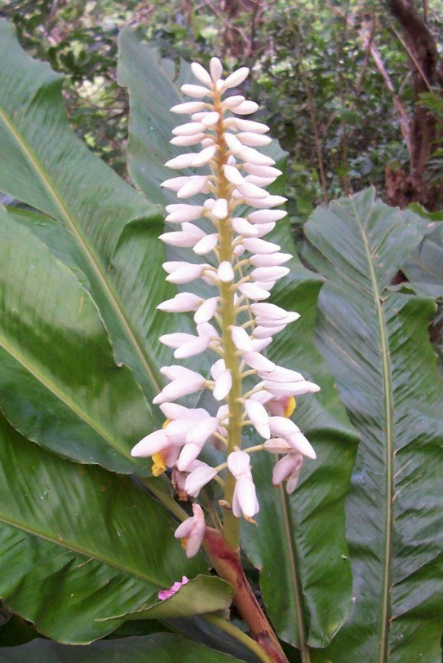
Name two consequences of deforestation:
1)__________________________________________________________________
2)__________________________________________________________________

Why did El Salvador lose 70-85% of its rainforest in 1984-1985?
____________________________________________________________________________
What percentage of the rainforest has South America lost?
__%

Fill in the blank.
Indigenous people _______ in the rainforest. They depend on the forest for their food, clothing, medicine, cooking and building materials.
What percentage of rainforests remaining are located in the Neotropics?
__%

