Oakfield Home Learning Activities
From 23.3.20 to 3.4.20
Year 3
English

Wordsmith Logon.
Go to www.activelearnprimary.co.uk
Or go to school website www.oakfieldjunior.com and follow the links at the side of the page.

User name: First initial then space followed by last name. Eg Paul Smith = p smith
Password is: password
School code: XLPA
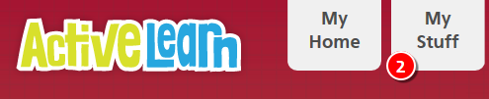

In My Stuff select the ‘Was Tutankhamen killed?’ book.



If you do not have easy access to the internet you could think about the stories we have read this year including:
The Stone Age Boy
The Twits
The Minpins

Think of one of the characters in the stories.
What questions would you like to ask the character?
- Write a story based on the characters in one of these stories.

Reading

Please read every day for 20 minutes. Don’t forget to fill in your planners to gain those house points for your house.

Oxford Owl for Home is a great online reading resource where the children can sign up for free and read E Books.
https://www.oxfordowl.co.uk/
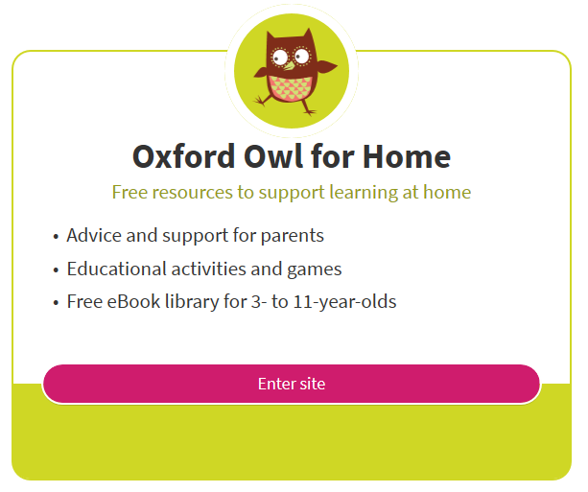
Spellings
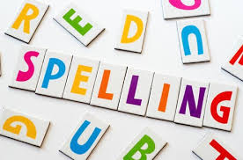
The statutory spellings for lower and upper KS2 are also at the back of your planner. Keep learning and practising these spellings, using the cover, write, check method or other strategies such as pyramids that you have been taught. Always make sure that you know the meaning of a word by looking it up in a dictionary if unsure.
Maths


Abacus Logon.
Go to www.activelearnprimary.co.uk
Or go to school website www.oakfieldjunior.com and follow the links at the side of the page.

User name: First initial then space followed by last name. Eg Paul Smith = p smith
Password is: password
School code: XLPA

In My Stuff select the Abacus work.


Learn to tell the time!
Play the online games to tell the time:
https://mathsframe.co.uk/en/resources/resource/116/telling-the-time

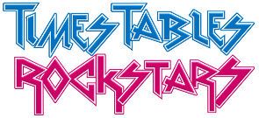

Log on to https://ttrockstars.com/
I have set you some new sessions to work through. Good luck!
It is important to practise your timestables facts. Your passwords are in your planners.
Science
Science- Forces
Watch the videos on https://www.bbc.co.uk/bitesize/topics/zvpp34j/resources/1
Create a poster about forces used in everyday life!
Topic
Log on to https://www.discoveryeducation.co.uk/

Select the Espresso dropdown box in the top right hand corner.
Username: student28853
Password: oaktree

When searching make sure Key Stage 2 is selected.

Search for ‘Egyptian God Arrives’
Watch the video where the statue of the ancient Egyptian god Anubis has been sailed up the River Thames to advertise a new exhibition of artefacts from the grave of the world's most famous pharaoh, Tutankhamun!
You can research this by looking at …
Articles or fact file.   |  | Play online activities.   |  | Explore the videos.  
Create a fact file for your favourite Egyptian Gods. Find information to research on:  https://www.historyforkids.net/egyptian-gods.html |  |  |  | 

We look forward to celebrating your Home Learning on your return to school. If you would like to email your teacher with the PowerPoint presentations, typed stories and photos of your learning activities ahead of returning to school you are welcome to do so.
Our email addresses are below:
emily_buckler@oakfield.surrey.sch.uk
suzanne_king@oakfield.surrey.sch.uk
ed_james@oakfield.surrey.sch.uk


Have fun with your learning BUT it’s important to:

chill and relax,   | eat healthily,   |  | exercise   |  | And get lots of sleep!  
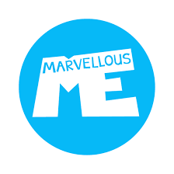
Your teachers may update you with ideas by using marvellous me.
There will also be updates on the website.
Below are addresses of websites for additional learning activities;

Don’t forget please be e-smart when researching anything on the internet.

General
http://www.crickweb.co.uk/
https://www.bbc.co.uk/bitesize
http://www.primaryhomeworkhelp.co.uk/
Non-Screen activities
https://www.primarygames.co.uk/pg4/Ghostblasters2006/ghost2006.swf
Primary Maths Games Ghostblasters the return – Another great online game for children to practise their times tables
https://blockly.games
Learn computer programming skills – fun and free.
Scratch
https://scratch.mit.edu/explore/projects/games/
Creative computer programming
https://www.natgeokids.com/uk/
Activities and quizzes for younger kids.
https://www.duolingo.com
Learn languages for free. Web or app.
https://mysteryscience.com
Free science lessons
https://thekidshouldseethis.com
Wide range of cool educational videos

