Maths Home Learning Programme: 3BK

It would be great if you could do a little Maths each day, but please aim for a minimum of 3 sessions each week. Here is a suggested outline for your maths sessions at home:

Tables 5m  Times Table Rockststars –At least 1 x 5 minute session every day:  www.ttrockstars.com | 5m Starter  Please follow the link below. A good introduction to maths activities and an excellent way to constantly revisit core skills. Start at bronze / silver levels. There is one challenge for everyday - start from the current date and work through (plus an answer sheet!)  https://corbettmathsprimary.com/5-a-day/  These sheets are also ideal if you are short on time and just want to do a short session to keep things ticking over. | 15m Main activity.  Aim for 2-3 sessions per week  We follow the White Rose Maths Scheme, which is being offered online free of charge including supportive video lesson, worksheet and answer sheet.  https://whiterosemaths.com/homelearning/year-3/  Please start at Week 1 Lesson 1 – it will continue the work we began on unit and non-unit fractions prior to the closure.  The programme will be added to each week so there will always be a full week of lessons to work through.  Don’t be tempted to skip ahead as the scheme relies upon building skills in small steps in sequence. Work through at your own individual pace. Repeat a session if necessary. | Consolidation session: Aim for a session each week  To constantly review core areas of the curriculum that we have already covered, please use the following online service. Try to include this on one day each week. Try to complete 1- 2 units in per week.  https://corbettmathsprimary.com/content/  For each topic there is a video lesson, worksheet and answer sheet.  The following support work completed so far in Y3:  - Addition: Column method video 1  - Division: Bus stop video 19  - Fractions (adding same denominator): video 23  - Fractions: Equivalent video 26  - Fractions of amounts: video 29  - *Money: video 37  - Multiples: video 38  - Ordering numbers: video 43  - Place Value: video 50  - Rounding: video 56  - Sequences: video 57  - Subtraction: video 63  - Think of a number: video 65  - Time: video 66  - Words/figures: video 76  *Money: we were going to teach money after Easter. Any ‘hands on’ practice using real coins/notes would be beneficial.
For additional challenges and interactive maths games  http://www.iseemaths.com/home-lessons/  https://www.topmarks.co.uk/maths-games/7-11-years/ |  |  | For a fun daily challenge for all the family with solutions :)  https://whiterosemaths.com/resources/classroom-resources/problems/

 | Monday | Tuesday | Wednesday | Thursday | Friday
TT Rockstars  Sessions have been set for every child – 1 studio session per day. | 5mins in sound studio mode  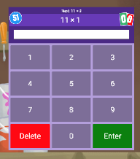 | 5mins in sound studio mode | 5mins in sound studio mode | 5mins in sound studio mode | 5mins in sound studio mode
5 A Day – Daily starter activity. Please try to complete one every day. | 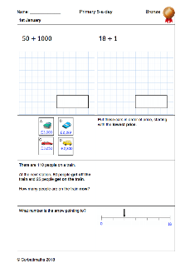 | 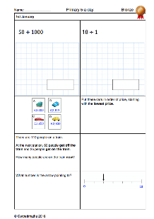
New Learning Lesson – Aim for 2-3 sessions per week. Children follow the online lesson and activity. | 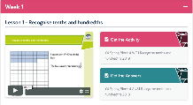
Consolidation.  Try to complete 1- 2 units per week | 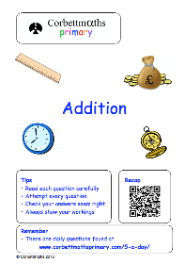
Anytime challenges – short on time or want an additional challenge | 

