Maths Home Learning Programme: Year 4 Maths Treens’ group
Tables 5m  Times Table Rockststars  All children have been set challenges to complete over the course of one week.  Log on and children should be directed to their work areas.  www.ttrockstars.com | 5m Starter  Please follow the link below. A good introduction to maths activities and an excellent way to constantly revisit core skills. Start at bronze / silver levels. There is one challenge for everyday - start from the current date and work through (plus an answer sheet!)  https://corbettmathsprimary.com/5-a-day/  These sheets are also ideal if you are short on time and just want to do a short session to keep things ticking over. | 15m Main activity.  Aim for 2-3 sessions per week  We follow white rose maths scheme, which is being offered online free of charge including supportive video lesson, worksheet and answer sheet.  https://whiterosemaths.com/homelearning/year-4/  Please start at SUMMER Week 1 Lesson 1 (Make a whole)  The programme will be added to each week so there will always be a full week of lessons to work through.  Don’t be tempted to skip ahead as the scheme relies upon building skills in small steps in sequence. Work through at your own individual pace. Repeat a session if necessary.  Extension sheets :  Please download the extension maths documents, linked to the white rose  Year-4-Summer-Block 2-Week 1-lesson 3-Extension-Compare-Decimals  Year-4-Summer-Block-2-Week 1-lesson 4-Extension-Order-Decimals  Year-4-Summer-Block-2-Week 2-lesson 1-Extension-Round-Decimals  Year-4-Summer-Block-2-Week 2-lesson 2-Extension-Halves-and-Quarters | Consolidation session: Aim for ONE session each week  To constantly review core areas of the curriculum that we have already covered, please use the following online service. Try to include this on one day each week. Try to complete 1- 2 units per week.  https://corbettmathsprimary.com/content/  For each topic there is a video lesson, worksheet and answer sheet.  The following support work completed so far in Y4:  - Place Value: Video 50  - Ordering numbers – video 43  - Addition – video 1  - Subtraction – video 63  - X by 10,100,1000 – video 40  - ‘/. By 10,100,1000 – video 18  - Adding Fractions – video 23  - Equivalent Fractions – video 26  - Fractions of an amount – video 29  - Ordering fractions – video 30  - Roman numerals - video 55  - 2D Shapes – video 58  - Factors – video 22  - Multiples – video 38  - Prime numbers – video 51  - Rounding – video 56  - Perimeter – video 47  - Area rectangle – video 47  - Negative numbers –video 41
For additional challenges and interactive maths games  http://www.iseemaths.com/home-lessons/  https://www.topmarks.co.uk/maths-games/7-11-years/ |  |  | For a fun daily challenge for all the family with solutions :)  https://whiterosemaths.com/resources/classroom-resources/problems/

 | Monday | Tuesday | Wednesday | Thursday | Friday
TT Rockstars  Sessions have been set for every child – 1 studio session per day. | 5mins in sound studio mode  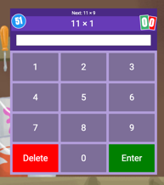 | 5mins in sound studio mode | 5mins in sound studio mode | 5mins in sound studio mode | 5mins in sound studio mode
5 A Day – Daily starter activity. Please try to complete one every day. | 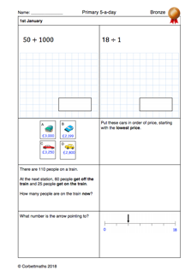 | 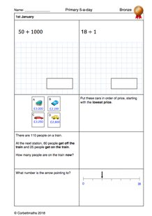
New Learning Lesson – Aim for 2-3 sessions per week. Children follow the online lesson and activity. | 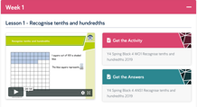
Consolidation.  Try to complete 1- 2 units per week | 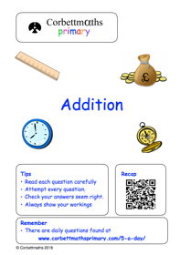
Anytime challenges – short on time or want an additional challenge | 

