Oakfield Junior School
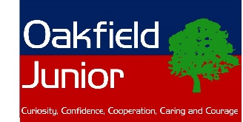

Year 4 Resources for fun Music Learning

Daily Singing:
Singing is a great way to lift your mood and have some fun!
Visit https://www.outoftheark.co.uk for a new song each day!
Each free song comes with a resource you can download, with activity ideas.
Particularly recommended:
Wellbeing Wednesday and Thinking Thursday.
Enjoy having a sing song! We’ll choose our favourites to share once we’re all back together at school.
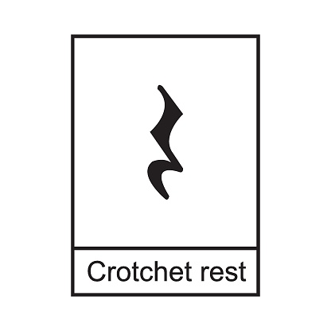

Clapping Activity, Reading Music:
We have been learning about rhythms and getting really good at reading and clapping them.
Here is a link to a fun activity (click on the link beneath the picture).
The music was composed by Tchaikovsky, a Russian composer.
It is called Dance of the Sugar Plum Fairy.
See if you can follow the rhythm and clap the correct rhythms.
Remember that a crotchet lasts for 1 beat, a quaver for ½ a beat
and a minim for 2 beats. A crotchet rest is a one beat silence.
It looks a little bit like a seagull if you tip your head to the side!
https://www.youtube.com/watch?v=qC3ZlV0ppAc

Present your findings as a colourful and informative poster.
Year 4
research project:

The music of the
1970s
ABBA
You can either write and draw by hand, or use a computer.

Be sure to include:
- Factual information
- A map showing important places
- Pictures of key people
- The names of any songs you were able to listen to.

Extra challenge:
- Can you make your own timeline of the decade,
showing key events?
Please don’t forget to be e-smart when researching anything on the internet. Please check you have permission to be online from a grown up. When you are watching something on YouTube, do not watch follow on videos – only those with direct links from this sheet.

