Oakfield Home Learning Activities
From 23.3.20 to 3.4.20
Year 5
English

Wordsmith Logon.
Go to www.activelearnprimary.co.uk
Or go to school website www.oakfieldjunior.com and follow the links at the side of the page.

User name: First initial then space followed by last name. Eg Paul Smith = p smith
Password is: password
School code: XLPA


- Open Active Learn. In My Stuff select the Greek Myths book.
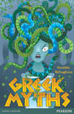
Then complete:
- Comprehension 1
- Comprehension 2

If you do not have a printer to print out the worksheets, you can just work on lined or plain paper

2. Write a diary entry in the role of Titania. How was Titania feeling after her argument with Oberon? What did Puck give her and what did it make her do? How did she feel about Bottom? You may type your diary or write it up.

Reading

Please read every day for 25 minutes. Don’t forget to fill in your planners to gain those house points for your house.

Oxford Owl for Home is a great online reading resource where the children can sign up for free and read E Books.
https://www.oxfordowl.co.uk/
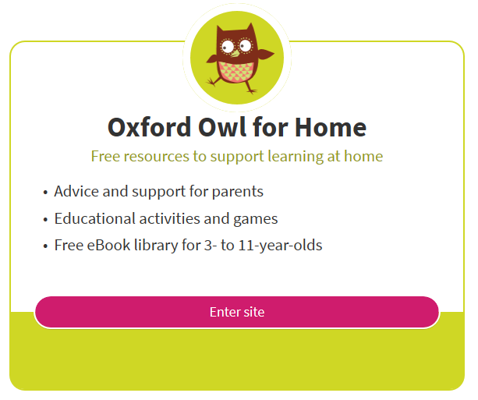
Spellings
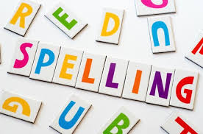
The statutory spellings for lower and upper KS2 are also at the back of your planner. Keep learning and practising these spellings, using the cover, write, check method or other strategies such as pyramids that you have been taught. Always make sure that you know the meaning of a word by looking it up in a dictionary if unsure.
Maths


Abacus Logon.
Go to www.activelearnprimary.co.uk
Or go to school website www.oakfieldjunior.com and follow the links at the side of the page.

User name: First initial then space followed by last name. Eg Paul Smith = p smith
Password is: password
School code: XLPA

In My Stuff select the Abacus work.


1. Estimating angles – Use this website to practise estimating the size of angles. Can you improve your accuracy so that you are within 5 degrees? Estimating angles? https://nrich.maths.org/1235 3.
2. Area – Use this website for inspiration to design a patio made from different sized tiles. Your final patio area needs to be a 10 by 10square. Tiles on a patio - https://nrich.maths.org/35
3. In My Stuff we have allocated 2 activities for you to complete onmultiplication and division.


Log on to https://ttrockstars.com/
Have fun! Good luck!
It is imprtant to practise your timestables facts. Your passwords are in your planners.
Arithmetic Revision

For practise tasks click the link here:
Science
Log on to https://www.discoveryeducation.co.uk/

Select the Espresso dropdown box in the top right hand corner.
Username: student28853
Password: oaktree

When searching make sure Key Stage 2 is selected.

Plan and conduct an investigation to answer the question: Does the temperature of water affect the speed that sugar dissolves?
You will need to write a report about your findings that will include:
• How you made the test fair
• Accurate repeated measurements and clear presentation of results (table/chart/graph)
• A conclusion that includes any improvements you might need to make to your test
• Suggestions for further tests to investigate other factors that could affect the rate at which sugar dissolves (you may want to try another test)
History and Geography
Log on to https://www.discoveryeducation.co.uk/

Select the Espresso dropdown box in the top right hand corner.
Username: student28853
Password: oaktree

When searching make sure Key Stage 2 is selected.

History Write your own version of the Trojan Horse story but from Prince Paris, Queen Helen, King Menelaus, a warrior inside the horse or another character’s point of view. Empathise with them.

Geography
Use the geography sheet on Global Warming we sent home with you, and compete the activity.
We look forward to celebrating your Home Learning on your return to school. If you would like to email your teacher with the PowerPoint presentations, typed stories and photos of your learning activities ahead of returning to school you are welcome to do so.
Our email addresses are below:
Staff email addresses
Cheryl_martin@oakfield.surrey.sch.uk
Julie_gumbrell@oakfield.surrey.sch.uk
Katie_holden@oakfield.surrey.sch.uk
Simon_Barrett@oakfield.surrey.sch.uk


Have fun with your learning BUT it’s important to:

chill and relax,   | eat healthily,   | exercise   | And get lots of sleep!  

Your teachers may update you with ideas by using marvellous me.
There will also be updates on the website.
Below are addresses of websites for additional learning activities;

Don’t forget please be e-smart when researching anything on the internet.

General
http://www.crickweb.co.uk/
https://www.bbc.co.uk/bitesize
http://www.primaryhomeworkhelp.co.uk/
Non-Screen activities
https://www.primarygames.co.uk/pg4/Ghostblasters2006/ghost2006.swf
Primary Maths Games Ghostblasters the return – Another great online game for children to practise their times tables
https://blockly.games
Learn computer programming skills – fun and free.
Scratch
https://scratch.mit.edu/explore/projects/games/
Creative computer programming
https://www.natgeokids.com/uk/
Activities and quizzes for younger kids.
https://www.duolingo.com
Learn languages for free. Web or app.
https://mysteryscience.com
Free science lessons
https://thekidshouldseethis.com
Wide range of cool educational videos

