Reversible and Irreversible Changes
Look at the picture of the material in its original state, then draw a picture of it after heating.
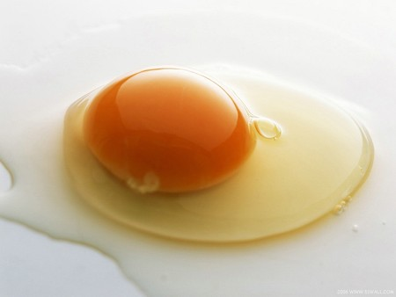 | Reversible or irreversible?
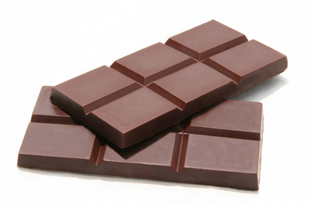 | Reversible or irreversible?
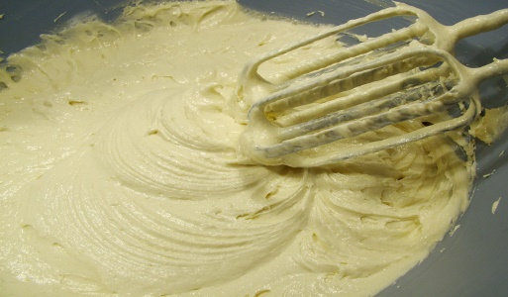 | Reversible or irreversible?
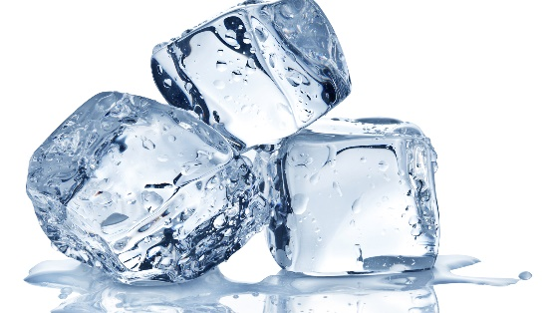 | Reversible or irreversible?
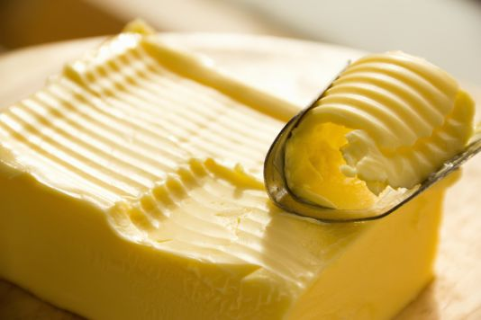 | Reversible or irreversible?
- What other reversible changes can you think of? Show them on the back of the sheet.
2) What other irreversible changes can you think of? Show them on the back of the sheet.

