Oakfield Home Learning Activities
From 23.3.20 to 3.4.20
Year 6
English

Wordsmith Logon.
Go to www.activelearnprimary.co.uk
Or go to school website www.oakfieldjunior.com and follow the links at the side of the page.

User name: First initial then space followed by last name. Eg Paul Smith = p smith
Password is: password
School code: XLPA


Tasks: 5 Reading Comprehension Tasks have been set on here for Y6 to complete:
- The Museum of Fun
- Mission: Save Pompeii
- The Warm and the Cold
- Animals on the Move
- If You Don’t Put Your Shoes On…

In My Stuff select the Eye of the Wolf book and finish the text (we have starting reading this in class already).
It is split into four parts (Part I, II, III and IV).
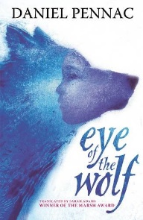


Spag.com
Log in as you have been doing for the previous two grammar homework tasks (details in
Planners). There is another assessment (Test C) ready for you to complete online.

Reading

Please read every day for 30 minutes. Don’t forget to fill in your planners to gain those house points for your house.

Oxford Owl for Home is a great online reading resource where the children can sign up for free and read E Books.
https://www.oxfordowl.co.uk/
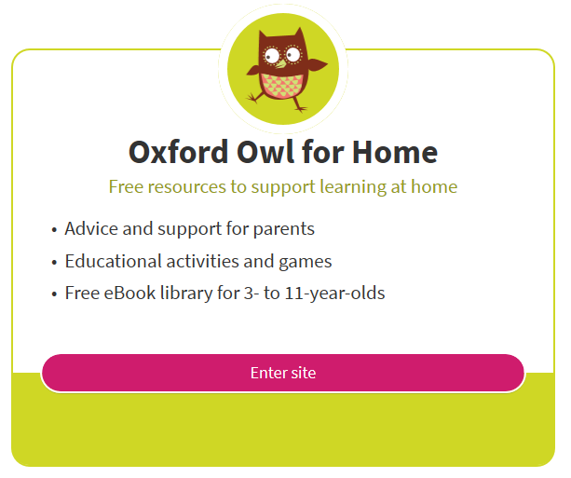
Spellings
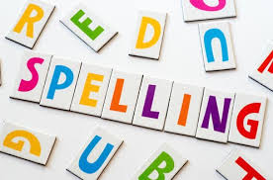
The statutory spellings for lower and upper KS2 are also at the back of your planner. Keep learning and practising these spellings, using the cover, write, check method or other strategies such as pyramids that you have been taught. Always make sure that you know the meaning of a word by looking it up in a dictionary if unsure.

Maths
Please complete your ‘Raising the Standards’ Maths Homework book (the little yellow or blue ones).
There are around 7 tasks left to complete so try to do one each day.



Log on to https://ttrockstars.com/
Perhaps you could co-ordinate a time with some of your classmates and set up a class battle!
It is imprtant to practise your timestables facts. Your passwords are in your planners.

Arithmetic Revision

For practise tasks click the link here:
https://oiyuyuy.exampro.net/

This 30-mark arithmetic test which should take approximately 30 minutes under timed, exam conditions. There is an option to print the paper, or answers can be recorded in children’s maths homework book directly from the screen if preferred.

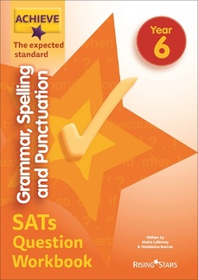
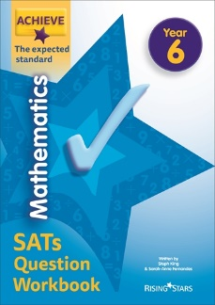
Rising Stars
Please remember many of you also have your
‘Rising Stars’ Revision books for Maths, Reading
and Spag revision. Work through at your own pace.

Science
Log on to https://www.discoveryeducation.co.uk/

Select the Espresso dropdown box in the top right hand corner.
Username: student28853
Password: oaktree

When searching make sure Key Stage 2 is selected.

Tasks: Search for: Classification
Scroll down and look for the following online activities to play:

- Classify it! Vertebrates and invertebrates.
- Classify it! Animal groups.
- King of the 5 Kingdoms Quiz

You could also explore this video:

- What’s in a name?

Topic
Log on to https://www.discoveryeducation.co.uk/

Select the Espresso dropdown box in the top right hand corner.
Username: student28853
Password: oaktree

When searching make sure Key Stage 2 is selected.

Search for: National Parks

Now see link (on Oakfield school website, on the Home Learning Year 6 Page) to PowerPoint explaining your task. This PowerPoint lesson was taught to both Y6 classes on Wednesday 18th March so any pupils who were in school that day have had the task explained. If your child was absent, the task is clearly outlined on the slides.


We look forward to celebrating your Home Learning on your return to school. If you would like to email your teacher with the PowerPoint presentations, typed stories and photos of your learning activities ahead of returning to school you are welcome to do so.
Our email addresses are below:
gary_myers@oakfield.surrey.sch.uk
rachael_cole@oakfield.surrey.sch.uk
verity_ketteringham@oakfield.surrey.sch.uk


Have fun with your learning BUT it’s important to:

chill and relax,   | eat healthily,   | exercise   | And get lots of sleep!  

Your teachers may update you with ideas by using marvellous me.
There will also be updates on the website.
Below are addresses of websites for additional learning activities:

Don’t forget please be e-smart when researching anything on the internet.

General
http://www.crickweb.co.uk/
https://www.bbc.co.uk/bitesize
http://www.primaryhomeworkhelp.co.uk/
Non-Screen activities
https://www.primarygames.co.uk/pg4/Ghostblasters2006/ghost2006.swf
Primary Maths Games Ghostblasters the return – Another great online game for children to practise their times tables
https://blockly.games
Learn computer programming skills – fun and free.
Scratch
https://scratch.mit.edu/explore/projects/games/
Creative computer programming
https://www.natgeokids.com/uk/
Activities and quizzes for younger kids.
https://www.duolingo.com
Learn languages for free. Web or app.
https://mysteryscience.com
Free science lessons
https://thekidshouldseethis.com
Wide range of cool educational videos

