LO: To observe changes over time.

Follow these instructions to take a cutting from a plant and see if you can grow another plant from it.
You could take photographs to show the changes over time to your new plant.
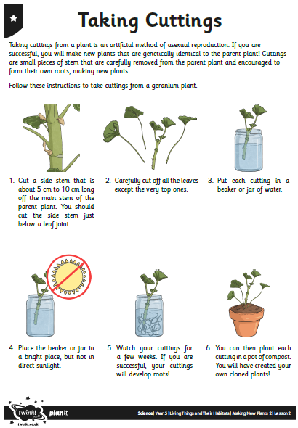
Let us know how you get on.

