Oakfield Junior School

Year 6 Resources for fun Music Learning

Daily Singing:
Singing is a great way to lift your mood and have some fun!
Visit https://www.outoftheark.co.uk for a new song each day!
Each free song comes with a resource you can download, with activity ideas.
Particularly recommended:
Wellbeing Wednesday and Thinking Thursday.
Enjoy having a sing song!
We’ll choose our favourites to share once we’re all back together at school.
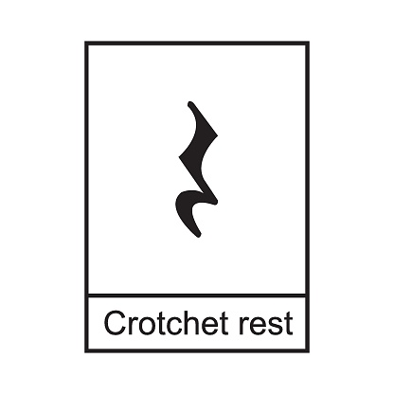
Clapping Activity, Reading Music
Timpani are large, tuned drums (sometimes called kettle drums.)
Here is a link to a fun activity (click on the link beneath the picture.)
Look out for note durations we have looked at together,
such as crotchet, quavers and minims.
Notice how a crotchet rest (silence) looks a bit like
a seagull flying sideways!
See if you can follow the music and play the correct drum
(tapping your left and right knee) with the right rhythms.

Year 6
research project:

The music of the
1990s

Britpop

https://www.youtube.com/watch?v=sYxxlsUDYQ4

Design a powerpoint presentation to teach the rest of your class what you have discovered about Britpop.

Be sure to include:
- Factual information
- A map showing important places
- Pictures of key people
- The names of any songs you were able to listen to.

Extra challenge:
- Can you make your own timeline of the decade,
showing key events?
Please don’t forget to be e-smart when researching anything on the internet. Please check you have permission to be online from a grown up. When you are watching something on YouTube, do not watch follow on videos – only those with direct links from this sheet.

