Oakfield Home Learning Activities
From 23.3.20 to 3.4.20
Year 4
English
Wordsmith Logon.
Go to www.activelearnprimary.co.uk
Or go to school website www.oakfieldjunior.com and follow the links at the side of the page.

User name: First initial then space followed by last name. Eg Paul Smith = p smith
Password is: password
School code: XLPA

In My Stuff select the Iron man book. Read up to chapter 3 first.
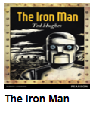
Then complete:
- Questions for the Iron Man sheet
- The Tension Chart.
If you do not have a printer to print out the worksheets, you can just work on lined or plain paper

After this continue with the story.
You can then have a go at:
- What happened to the Iron Man?
- Writing direct speech.

Finally you can have a go writing your own story based on the Iron Man. You can use the story planning sheet to help you.

If you do not have easy access to the internet you could think about the stories we have read this year including:
How to train your Dragon.
The Spiderwick Chronicles
The Fireworks maker daughter.

Think of one of the characters in the stories?
What questions would you like to ask the character?
Write a story based on the characters in one of these stories.
Reading
Please read every day for 20 minutes. Don’t forget to fill in your planners to gain those house points for your house.
Oxford Owl for Home is a great online reading resource where the children can sign up for free and read E Books.
https://www.oxfordowl.co.uk/
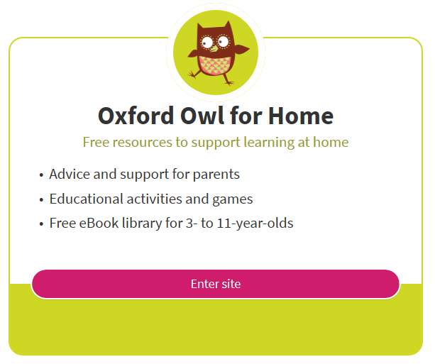
Spellings
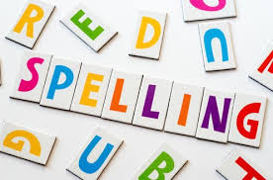
The statutory spellings for lower and upper KS2 are also at the back of your planner. Keep learning and practising these spellings, using the cover, write, check method or other strategies such as pyramids that you have been taught. Always make sure that you know the meaning of a word by looking it up in a dictionary if unsure.
Maths

Abacus Logon.
Go to www.activelearnprimary.co.uk
Or go to school website www.oakfieldjunior.com and follow the links at the side of the page.

User name: First initial then space followed by last name. Eg Paul Smith = p smith
Password is: password
School code: XLPA

In My Stuff select the Abacus work.

Mr Treen’s Set:
I have set some work based on our fraction and decimal units. Including x and ÷ by 10,100, 1000 , ordering numbers, equivalent fractions.

Mrs Moss’s Set:
I have set you some work which includes adding, subtract, multiplying and dividing.

Log on to https://ttrockstars.com/
I have set you some new sessions to work through. Good luck!
It is imprtant to practise your timestables facts. Your passwords are in your planners.
Science
Log on to https://www.discoveryeducation.co.uk/

Select the Espresso dropdown box in the top right hand corner.
Username: student28853
Password: oaktree

When searching make sure Key Stage 2 is selected.

Search for: Digestive System.
I would like you to create a poster that explains how the digestive system work.

You can research this by looking at articles or fact file. | Play online activities: |  |  |  | Explore the videos:
Topic
Log on to https://www.discoveryeducation.co.uk/

Select the Espresso dropdown box in the top right hand corner.
Username: student28853
Password: oaktree

When searching make sure Key Stage 2 is selected.

Search for: Vikings.
I would like you to answer the following questions:
Where and when did the Vikings exist?
What was daily life like?
What were houses and other buildings made from?
What did people wear?
What language did people speak?
What inﬂuences have the Vikings had on life in Britain today?
Would you like to have lived in Viking times? Why or why not?

You can research this by looking at …
Articles or fact file. |  |  | Play online activities. |  |  | Explore the videos.
We look forward to celebrating your Home Learning on your return to school. If you would like to email your teacher with the PowerPoint presentations, typed stories and photos of your learning activities ahead of returning to school you are welcome to do so.
Our email addresses are below:
james_treen@oakfield.surrey.sch.uk
paula_moss@oakfield.surrey.sch.uk

Have fun with your learning BUT it’s important to:

chill and relax, |  | eat healthily, |  | exercise |  |  | And get lots of sleep!
Your teachers may update you with ideas by using marvellous me.
There will also be updates on the website.
Below are addresses of websites for additional learning activities;
Don’t forget please be e-smart when researching anything on the internet.

General
http://www.crickweb.co.uk/
https://www.bbc.co.uk/bitesize
http://www.primaryhomeworkhelp.co.uk/
Non-Screen activities
https://www.primarygames.co.uk/pg4/Ghostblasters2006/ghost2006.swf
Primary Maths Games Ghostblasters the return – Another great online game for children to practise their times tables
https://blockly.games
Learn computer programming skills – fun and free.
Scratch
https://scratch.mit.edu/explore/projects/games/
Creative computer programming
https://www.natgeokids.com/uk/
Activities and quizzes for younger kids.
https://www.duolingo.com
Learn languages for free. Web or app.
https://mysteryscience.com
Free science lessons
https://thekidshouldseethis.com
Wide range of cool educational videos

